Recall that Machine Learning, the core process powering TinyML, is the process of having Data and Answers, and from them attempting to infer the rules that link them:



<Alt text: Answers and data feed into machine learning and from this rules emerge.>

So, if your **data** is the numbers in this set: [-1, 0 , 1, 2, 3, 4] , and your corresponding **answers** are the numbers in this set: [-3, -1, 1, 3, 5, 7], one way to begin to infer the relationship between them (assuming it’s linear) is to have a function, where we say Y = wX+b, and we have to try to figure out the values of w and b.

A process to do this is shown below:



<Alt text: Making a guess leads to measuring your accuracy which leads to optimizing your guess. This then gets repeated where you make a guess again and repeat the process. Arrows connect the steps.>

We could make a guess as to the values of w and b, and measure how accurate that guess is.

So, for example, if we guess that w=10, and b = -10, we would get the set of **answers** for our data as [-20, -10, 0, 10, 20, 30], where our *correct* answers are [-3, -1, 1, 3, 5, 7].

From this we can measure our *loss*, by plotting our predicted answer against our actual answer.

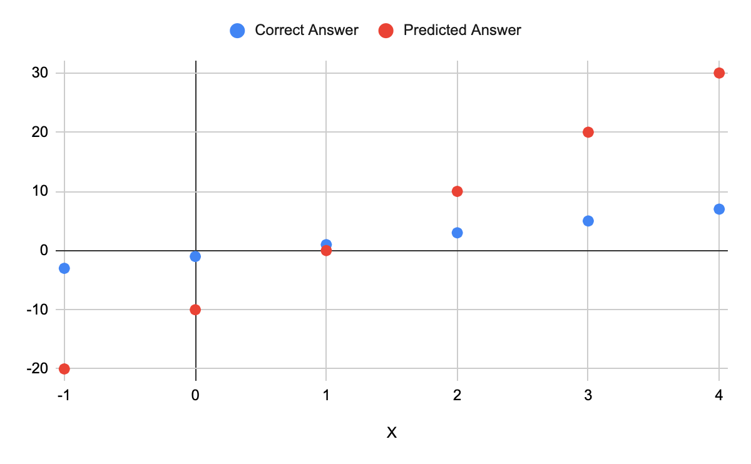

<Alt text: Scatter plot of predicted answer versus correct answer. Shows that the predictions are slightly off.>

So, for example, for x=-1, we predicted -20, when the answer is actually -3, so we are off by -17



<Alt text: Scatter plot of predicted answer versus correct answer. Shows that the predictions are slightly off. Example of a negative 17 gap at the x value of negative 1.>

And when x=3, we predicted the answer to be 20, when in fact it is supposed to be 5, so we have an error of 15.



<Alt text: Scatter plot of predicted answer versus correct answer. Shows that the predictions are slightly off. Example of a negative 15 gap at the x value of positive 3.>

If we want to find out our error, we could average each of these.

However, by doing this our negative (-17) and positive (15) errors would mostly cancel out, so the smart thing to do to ensure that we don’t have them do this is to *square* the error amount, average out the squares of the errors, and then get the square root of that.

This gives us a loss *function* of root mean squared error.

When we now want to optimize our guess, and do better than these results, we can look at the loss function, and figure out a way to minimize our loss. As the loss function uses a *square*, the curve of the function is parabolic.



<Alt text: Loss function curve. Goes from high point to low point and then to high point.>

And the value of our loss with our current parameters can be plotted on this. Our loss was high, so we can say we’re pretty far up the curve.



<Alt text: Loss function curve. Goes from high point to low point and then to high point. Ball is rolling downwards from the left hand side.>

When we differentiate our values against the loss function, we’ll get a gradient, and we can use the gradient to figure out which direction we have to go in to move down the slope!



<Alt text: Loss function curve. Goes from high point to low point and then to high point. Ball is rolling downwards from the left hand side. Arrow depicts a downwards gradient value.>

And we can then move down the slope in the direction derived from gradient. We’ll ‘jump’ by a certain amount, and we can call that amount the ‘Learning Rate’



<Alt text: Loss function curve. Goes from high point to low point and then to high point. Ball is rolling downwards from the left hand side. Arrow depicts a downwards gradient value. Additional arrow gives the learning rate which is the size of step to take.>

After that, we are now closer to the bottom of the curve. The parameters that give us our location on the curve can then be the next ‘guess’, and by definition, these will have a lower loss, and we can repeat the loop. This is called *back propagation*.



<Alt text: Loss function curve. Goes from high point to low point and then to high point. Ball is rolling downwards from the left hand side. Ball at a slightly lower point given the descent step.>

The process can be repeated, and over time the value will get closer and closer to the bottom of the parabola, which is the minimum value of the loss function.

This process of using the gradient of the value to figure out the direction of the minimum, and then jumping down the curve towards the minimum is called *gradient descent.*